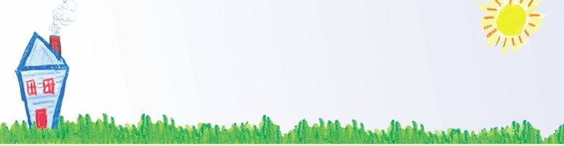
Greendale Elementary
Community School Society
(GECSS)

2021/2022 School Year

Anti-Spam Email Permission Form
Canada’s Anti-Spam Legislation Law came into effect on July 1, 2014. As a result we would like to ensure that we have your WRITTEN CONSENT to receive emails from us regarding GECSS Programs and Events at Greendale School.

If you would like to receive, or continue to receive this information from the GECSS Programs Office in the future, please complete the form below and return it to the school by October 15, 2021.

PLEASE NOTE – IF YOUR CONSENT IS NOT GIVEN, WE CANNOT EMAIL YOU ANY INFORMATION ABOUT ANY COMMUNITY SCHOOL PROGRAMS OR EVENTS. WE WILL NOT BE SEEKING CONSENT AGAIN
UNTIL SEPT. 2022.

If you would like your name removed our email list, let the GECSS Office know. Your email address will NOT be shared outside the GECSS Office.

If you have any questions, please don’t hesitate to ask. 😊

Andrea & Mayra

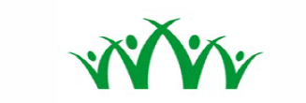
GECSS Anti-Spam Email Consent Form 2021/2022 School Year

Please PRINT CLEARLY.

Name: __________________________________________________________________________________

Email Address: __________________________________________________________________________
- I wish to receive GECSS emails containing information related to programs and events being offered at Greendale Elementary Community School or related to the Community School model. I can withdraw my consent at any time by emailing: coordinator@gecss.com

Signature: ______________________________________________________________________________

